### Logbook

During normal operation, all system events are registered chronologically. By clicking the *Logbook* button (see Figure 1‑1), these registered system events are displayed in a dedicated screen. It is also possible to show the logbook in any mimic (see Figure 1‑8).

#### Logbook groups

In order to separate various categories of information from each other, log entries are stored in various logging-groups. You can select them all or just a few of them, or even one if you need to focus on these entries. Just by selecting the category label at the top of the list, you filter the information you need (see Figure 1‑9).



Figure 1‑9: logging groups, all selected

|  |  |
| --- | --- |
| **Logging group** | **Explanation** |
| All Alarms | Alarms from all stations (even alarms you might not see on this station will be logged) |
| Alarms | All alarms from this station (all alarms that are visible on this station will be logged) |
| Serial | All serial information available on this station will be logged (initializing, finalizing and errors) |
| Network | All network information available on this station will be logged (Connecting, conn. Failed and errors) |
| Switching | All system, network and program switching |
| System | All process information and errors |

Table 2: Logging groups

#### Logbook appearance

All identical log entries that appear at the same time will be interconnected as shown in the following figure (see Figure 1‑10).

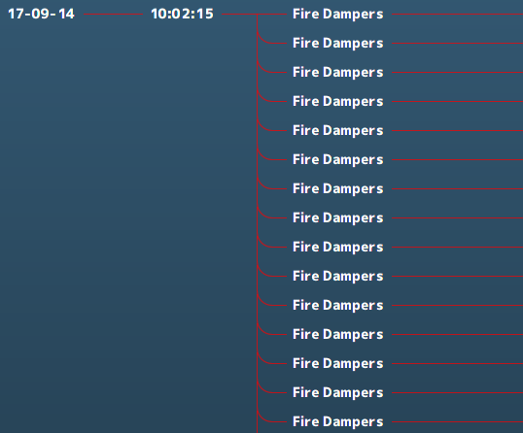

Figure 1‑10: interconnecting log appearance

#### Logbook status indication

All entries will have an explanatory status indication at the end of the entry line. This will give an indication about the reason that the indication is in the logbook (see Figure 1‑11).

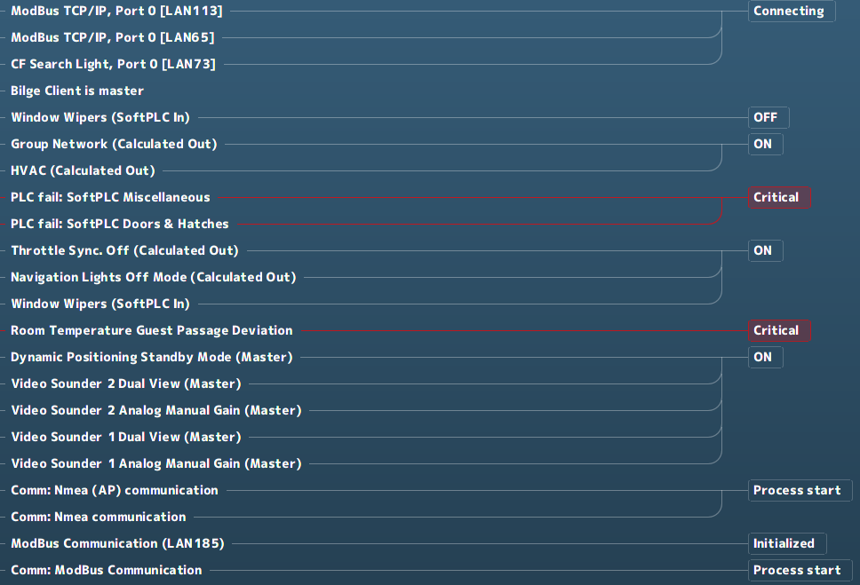

Figure 1‑11: Status indication log-entries

When logging alarms, this status indication will also be colored.

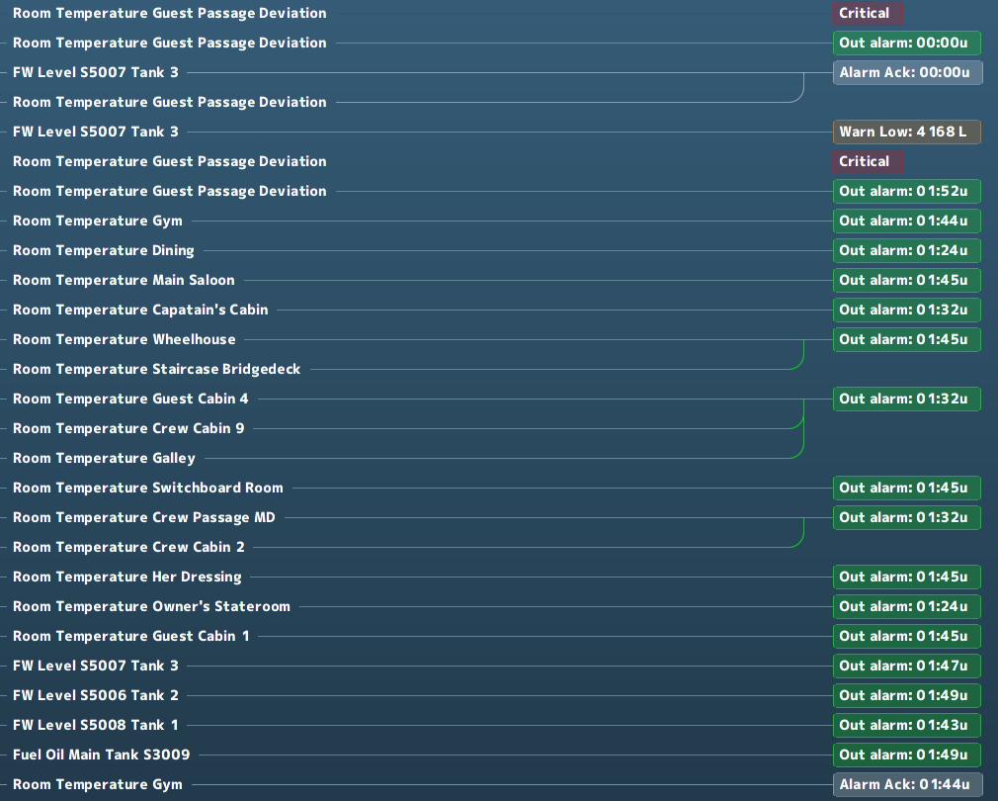

Figure 1‑12: Logging colors

|  |  |
| --- | --- |
| **Logging colors** | **Explanation** |
| Grey | Acknowledged |
| Green | Out of alarm or OK |
| Yellow | Caution |
| Orange | Warning |
| Red | Critical, Slowdown and Shutdown |

Table 3: Logbook colors

#### Logbook search bar and buttons

At the bottom of the logbook, you will find a search bar and a few buttons (see Figure 1‑13). In the search bar, you can click and type the name of the listing you are looking for. After hitting *Enter* the listing is shown, if available.



Figure 1‑13: Logbook search bar and buttons

If you click on the “From:” or “To:” on the search bar, a new window will appear (see Figure 1‑14). This window is a fully working calendar from which you can choose a “From” or “To” date. After you have entered the date and pressed the checkmark, the entries that occurred in the entered timeframe are shown.

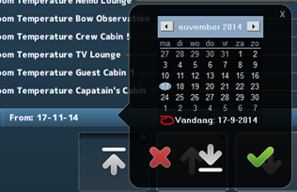

Figure 1‑14: Search calendar



Figure 1‑15: Print button



Figure 1‑16: Up- down buttons

If you click the *Print* button, you can print the logbook (if a printer is available). With the *Up* & *Down* buttons you can scroll to the top, up or down.